Name - Omkar Raushan

College - Lovely Professional University.

Project - Health Insurance-Premium-Prediction Using IBM Auto AI Service.

**Project Documentation**

1. Introduction :-

This project aims at building a web App that automatically estimates premium cost by taking the input values. 

Using IBM AutoAI, we automate all of the tasks involved in building predictive models for different requirements. You create a model from a data set that includes the age, gender, BMI, number of children, smoking preferences, region, and charges to predict the health insurance premium cost that an individual pays

The purpose of this project is to demonstrate how the factors like smoking and region affact the health of an individual.

Like the factor if a person is male or female do not have that much importance as compared to if he is a smoker or not.

There are other factos too which do not play an important role when it comes to the fact he the life insurance company should charge more or less such factos are namely region, sex, number of child. But the fact that a perosn is smoker or not and is age plays an important role in the premium cost which an individual has to pay. As we follow the project you will come to know it in a more better way

2. Literature Survey:-

As we see the value of gross insurance premiums worldwide continue to skyrocket past 5 trillion dollars, we know that most of these costs are preventable. For example, just by eliminating smoking, and lowering your BMI by a few points could mean shaving thousands of dollars off of your premium charges. In this application, we study the effects of age, smoking, BMI, gender, and region to determine how much of a difference these factors can make on your insurance premium. By using our application, customers see the radical difference their lifestyle choices make on their insurance charges. By leveraging AI and machine learning, we help customers understand just how much smoking increases their premium, by predicting how much they will have to pay within seconds.

The current time with technology like AI and machine learning can help us to deal with many problems. The AI models are so accurate that they can be trusted blindly.

And cam help us to solve many problem like this one where an Ai model is used to calculate the premium. It provid fast and reliable solution for our problem. The solution contains a data set and a AI model and give exceptionaly good results.

3. Theoretical Analysis:-

Using IBM AutoAI, you automate all the tasks involved in building predictive models for different requirements. You see how AutoAI generates great models quickly which save time and effort and aid in faster decision-making process. You create a model that from a data set that includes the age, sex, BMI, number-of-children, smoking preferences, region and charges to predict the health insurance premium cost that an individual pays.

When you have completed this code pattern, you understand how to:

* Setup, quickly, the services on IBM Cloud for building the model.
* Ingest the data and initiate the AutoAI process.
* Build different models using AutoAI and evaluate the performance.
* Choose the best model and complete the deployment.
* Generate predictions using the deployed model by making REST calls.
* Compare the process of using AutoAI and building the model manually.
* Visualize the deployed model using a front-end application.

4. Experimental Investigations:-

After associating data set with Ai model a experiment is set. This experiment is to creat different

pipelines with different levels of accuracy. The best set is considered the best pipeline and

furthur that is taken into consideration.

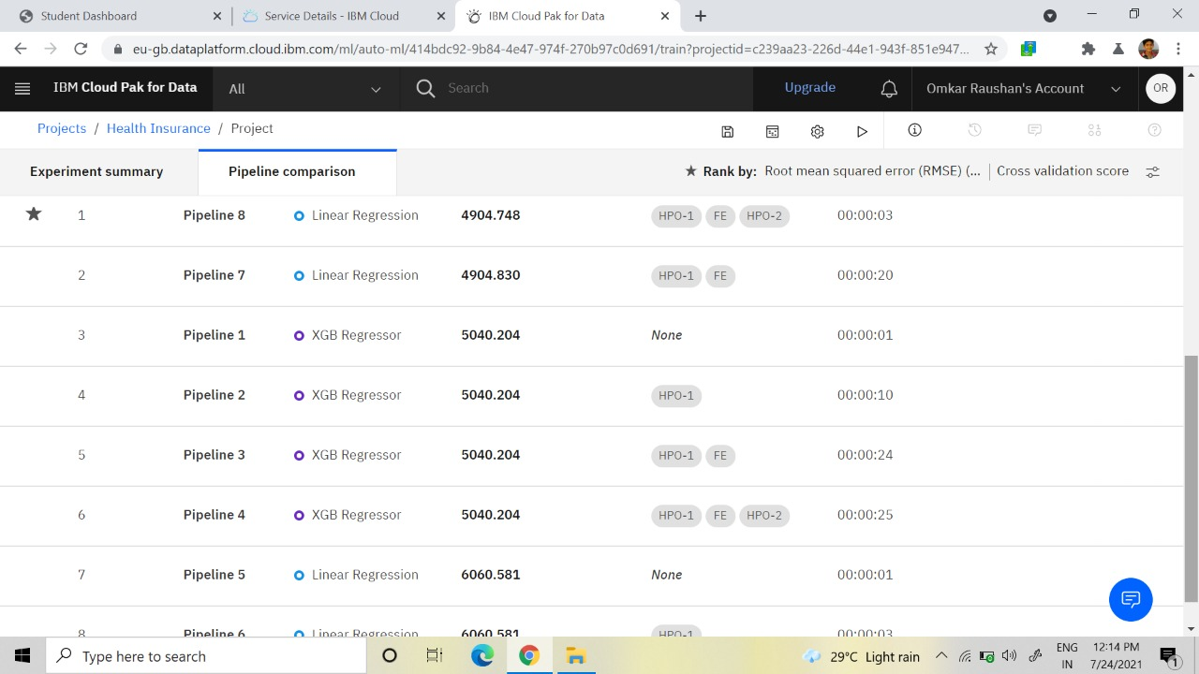

5. Flowchart :-

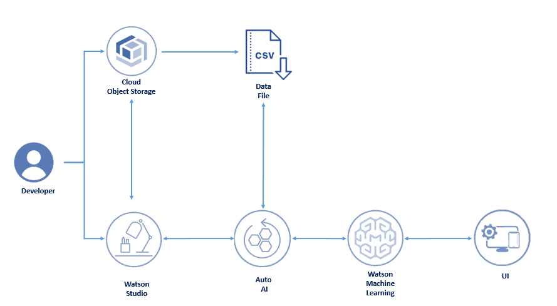

1- Creates an IBM Watson Studio Service on IBM Cloud.

2- Creates an IBM Cloud Object Storage Service and adds that to Watson Studio.

3- Uploads the insurance premium data file into Watson Studio.

4- Creates an AutoAI Experiment to predict insurance premium on Watson Studio

5- AutoAI uses Watson Machine Learning to create several models, and the user deploys the best performing model.

6- The user uses the Flask web-application to connect to the deployed model and predict an insurance charge

6. Result :-

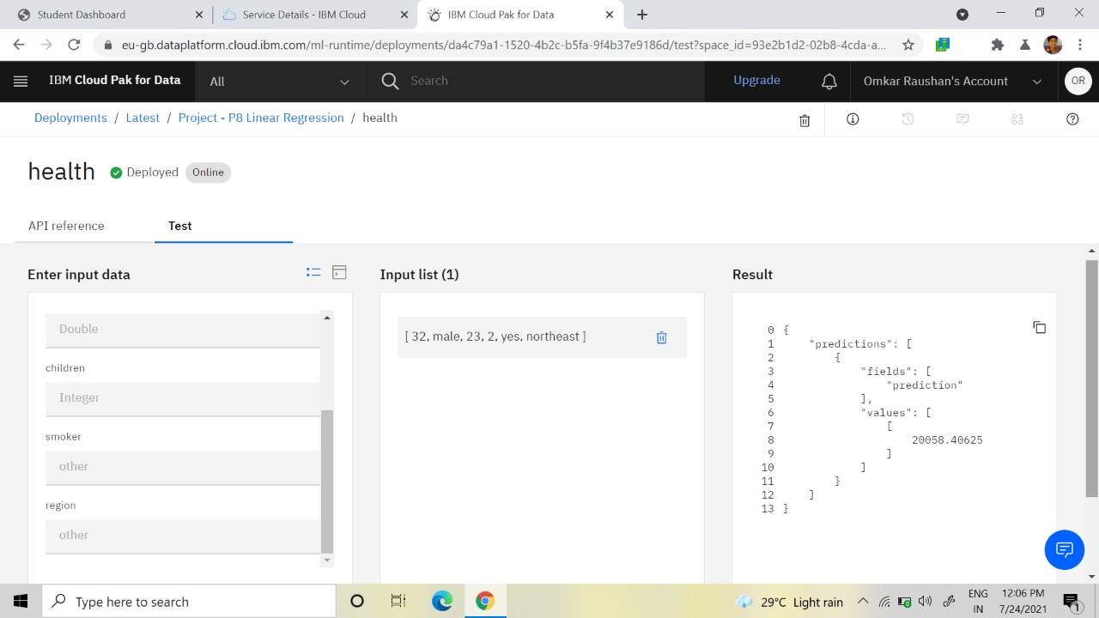

The results of the expermient were just perfect. As the model was working fine like for this perticular example the model shows that 13397.5 is the preimium for the person as his age is 22 he is male of course bmi is 20 he is not having any child and he is a smoker and he belongs to Southwest.

The model paid much importance to the factor if a person is a smoker or not.Smoking and age were the two most important factors for the premium.

7. Advantages & Disadvantages: -

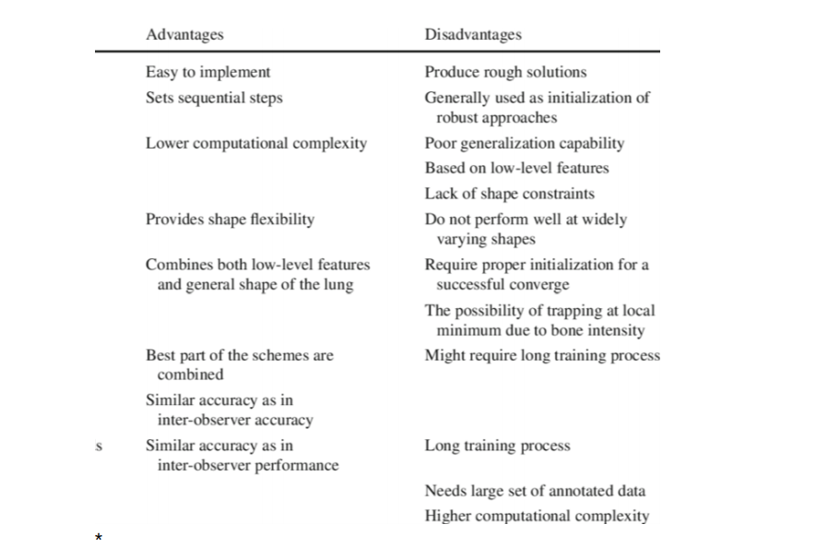

8. Applications :-

Application of this project or model can be found at many places and ***particullary***

in the insurance companies.

To charge the correct amount was always a big deal for both the customer and the service provider.

Using this web app we can just predict the correct amount which an individual shoud be paying

Below is the chart which is having anme of the co. which are using these kind of application

to predict the correct amount of premium.

|  |  |
| --- | --- |
|  |  |
|  |  |
|  |  |
|  |  |
|  |  |
|  |  |
|  |  |
|  |  |
|  |  |
|  |  |
|  |  |
|  |  |
|  |  |
|  |  |
|  |  |
|  |  |
|  |  |
|  |  |
|  |  |
|  |  |
|  |  |
|  |  |
|  |  |

9. Conclusion:-

Artificial Intelligence and Machine Learning are products of both science and myth. The idea that machines could think and perform tasks just as humans do is thousands of years old. The cognitive truths expressed in AI and Machine Learning systems are not new either. It may be better to view these technologies as the implementation of powerful and long-established cognitive principles through engineering.

We should accept that there is a tendency to approach all important innovations as a Rorschach test upon which we impose anxieties and hopes about what constitutes a good or happy world. But the potential of AI and machine intelligence for good does not lie exclusively, or even primarily, within its technologies. It lies mainly in its users. If we trust (in the main) how our societies are currently being run then we have no reason not to trust ourselves to do good with these technologies. And if we can suspend presentism and accept that ancient stories warning us not to play God with powerful technologies are instructive then we will likely free ourselves from unnecessary anxiety about their use.

10. Future Scope :-

Artificial Intelligence(AI) is the simulation of human intelligence by machines. In other words, it is the method by which machines demonstrate certain aspects of human intelligence like learning, reasoning and self- correction. Since its inception, AI has demonstrated unprecedented growth. Sophia the AI Robot, is the quintessential example of this. The future of Artificial intelligence is hazy. But going by the bounds of progress AI has been making, it is clear AI will permeate every sphere of our life. Listed below are the diverse ways in which AI can change in the future.

The scope of AI in science is the largest. Recently ‘Eve’ was in the news for discovering that an ingredient found commonly in toothpaste, is capable of curing Malaria. Here the subject in appreciation ‘Eve’ is not a human scientist, rather a Robot created by a team of scientists at the Universities of Manchester, Aberystwyth, and Cambridge.

The future application of AI in cybersecurity will ensure in curbing hackers. The incidence of cybercrime is an issue that has been escalating through the years. It costs enterprises in term of brand image as well as material cost. Credit card fraudery is one of the most prevalent cybercrimes. Despite there being detection techniques, they still prove to be ineffective in curbing hackers. AI can bring a remarkable change to this. Novel AI techniques like Recurrent Neural Networks can detect fraudery in initial stages itself. This fraud detection system will be able to scan thousands of transactions instantly and predict/ classify them into buckets. RNN can save a lot of time as it focuses on cases where there is a high probability for fraud.

Tech has advanced in terms of Emotional Quotient. Virtual assistants [Siri](https://www.apple.com/in/ios/siri/), Cortana & Alexa show how the extent to which AI comprehends human language. They are able to understand the meaning from context and make intelligent judgments. Back in 2015, a companion robot called, ‘Pepper’ went on sale. All the initial 1000 units were sold within a minute. Overall, considering all this, the possibility of emotional bots might become a reality in the future.

11. Bibliography:-

* IBM CLOUD.
* PYTHON.ORG
* MEDIUM.COM
* WATSON STUDIOS LEARNING.
* NODE RED LEARNING.
* SMARTINTERNZ.COM.
* YOUTUBE.COM.
* WIKIPEDIA.

12. Appendix:-

Source code-

#attempt import of autoai_libs and install if missing

try:

import autoai_libs

except Exception as e:

print('attempting to install missing autoai_libs from pypi, this may take tens of seconds to complete.')

import subprocess

try:

# attempt to install missing autoai-libs from pypi

out = subprocess.check_output('pip install autoai-libs', shell=True)

for line in out.splitlines():

print(line)

except Exception as e:

print(str(e))

try:

import autoai_libs

except Exception as e:

print('attempting to install missing autoai_libs from local filesystem, this may take tens of seconds to complete.')

import subprocess

# attempt to install missing autoai-libs from local filesystem

try:

out = subprocess.check_output('pip install .', shell=True, cwd='software/autoai_libs')

for line in out.splitlines():

print(line)

import autoai_libs

except Exception as e:

print(str(e))

import sklearn

try:

import xgboost

except:

print('xgboost, if needed, will be installed and imported later')

try:

import lightgbm

except:

print('lightgbm, if needed, will be installed and imported later')

from sklearn.cluster import FeatureAgglomeration

import numpy

from numpy import inf, nan, dtype, mean

from autoai_libs.sklearn.custom_scorers import CustomScorers

from autoai_libs.cognito.transforms.transform_utils import TExtras, FC

from autoai_libs.transformers.exportable import *

from autoai_libs.utils.exportable_utils import *

from sklearn.pipeline import Pipeline

known_values_list=[]

# compose a decorator to assist pipeline instantiation via import of modules and installation of packages

def decorator_retries(func):

def install_import_retry(*args, **kwargs):

retries = 0

successful = False

failed_retries = 0

while retries < 100 and failed_retries < 10 and not successful:

retries += 1

failed_retries += 1

try:

result = func(*args, **kwargs)

successful = True

except Exception as e:

estr = str(e)

if estr.startswith('name ') and estr.endswith(' is not defined'):

try:

import importlib

module_name = estr.split("'")[1]

module = importlib.import_module(module_name)

globals().update({module_name: module})

print('import successful for ' + module_name)

failed_retries -= 1

except Exception as import_failure:

print('import of ' + module_name + ' failed with: ' + str(import_failure))

import subprocess

print('attempting pip install of ' + module_name)

process = subprocess.Popen('pip install ' + module_name, shell=True)

process.wait()

try:

print('re-attempting import of ' + module_name)

module = importlib.import_module(module_name)

globals().update({module_name: module})

print('import successful for ' + module_name)

failed_retries -= 1

except Exception as import_or_installation_failure:

print('failure installing and/or importing ' + module_name + ' error was: ' + str(

import_or_installation_failure))

raise (ModuleNotFoundError('Missing package in environment for ' + module_name +

'? Try import and/or pip install manually?'))

elif type(e) is AttributeError:

if 'module ' in estr and ' has no attribute ' in estr:

pieces = estr.split("'")

if len(pieces) == 5:

try:

import importlib

print('re-attempting import of ' + pieces[3] + ' from ' + pieces[1])

module = importlib.import_module('.' + pieces[3], pieces[1])

failed_retries -= 1

except:

print('failed attempt to import ' + pieces[3])

raise (e)

else:

raise (e)

else:

raise (e)

if successful:

print('Pipeline successfully instantiated')

else:

raise (ModuleNotFoundError(

'Remaining missing imports/packages in environment? Retry cell and/or try pip install manually?'))

return result

return install_import_retry

# Metadata used in retrieving data and computing metrics. Customize as necessary for your environment.

#data_source='replace_with_path_and_csv_filename'

target_label_name = _input_metadata['target_label_name']

learning_type = _input_metadata['learning_type']

optimization_metric = _input_metadata['optimization_metric']

random_state = _input_metadata['random_state']

cv_num_folds = _input_metadata['cv_num_folds']

holdout_fraction = _input_metadata['holdout_fraction']

if 'data_provenance' in _input_metadata:

data_provenance = _input_metadata['data_provenance']

else:

data_provenance = None

if 'pos_label' in _input_metadata and learning_type == 'classification':

pos_label = _input_metadata['pos_label']

else:

pos_label = None

# @hidden_cell

# The following code contains the credentials for a file in your IBM Cloud Object Storage.

# You might want to remove those credentials before you share your notebook.

credentials_0 = {

}

# Read the data as a dataframe

import pandas as pd

csv_encodings=['UTF-8','Latin-1'] # supplement list of encodings as necessary for your data

df = None

readable = None # if automatic detection fails, you can supply a filename here

# First, obtain a readable object

# IBM Cloud Object Storage data access

# Assumes COS credentials are in a dictionary named 'credentials_0'

cos_credentials = df = globals().get('credentials_0')

if readable is None and cos_credentials is not None:

print('accessing data via IBM Cloud Object Storage')

try:

import types

from botocore.client import Config

import ibm_boto3

def __iter__(self): return 0

if 'SERVICE_NAME' not in cos_credentials: # in case of Studio-supplied credentials for a different dataset

cos_credentials['SERVICE_NAME'] = 's3'

client = ibm_boto3.client(service_name=cos_credentials['SERVICE_NAME'],

ibm_api_key_id=cos_credentials['IBM_API_KEY_ID'],

ibm_auth_endpoint=cos_credentials['IBM_AUTH_ENDPOINT'],

config=Config(signature_version='oauth'),

endpoint_url=cos_credentials['ENDPOINT'])

try:

readable = client.get_object(Bucket=cos_credentials['BUCKET'],Key=cos_credentials['FILE'])['Body']

# add missing __iter__ method, so pandas accepts readable as file-like object

if not hasattr(readable, "__iter__"): readable.__iter__ = types.MethodType( __iter__, readable )

except Exception as cos_access_exception:

print('unable to access data object in cloud object storage with credentials supplied')

except Exception as cos_exception:

print('unable to create client for cloud object storage')

# IBM Cloud Pak for Data data access

project_filename = globals().get('project_filename')

if readable is None and 'credentials_0' in globals() and 'ASSET_ID' in credentials_0:

project_filename = credentials_0['ASSET_ID']

if project_filename is not None:

print('attempting project_lib access to ' + str(project_filename))

try:

from project_lib import Project

project = Project.access()

storage_credentials = project.get_storage_metadata()

readable = project.get_file(project_filename)

except Exception as project_exception:

print('unable to access data using the project_lib interface and filename supplied')

# Use data_provenance as filename if other access mechanisms are unsuccessful

if readable is None and type(data_provenance) is str:

print('attempting to access local file using path and name ' + data_provenance)

readable = data_provenance

# Second, use pd.read_csv to read object, iterating over list of csv_encodings until successful

if readable is not None:

for encoding in csv_encodings:

try:

df = pd.read_csv(readable, encoding=encoding)

print('successfully loaded dataframe using encoding = ' + str(encoding))

break

except Exception as exception_csv:

print('unable to read csv using encoding ' + str(encoding))

print('handled error was ' + str(exception_csv))

if df is None:

print('unable to read file/object as a dataframe using supplied csv_encodings ' + str(csv_encodings))

print("Please use 'insert to code' on data panel to load dataframe.")

raise(ValueError('unable to read file/object as a dataframe using supplied csv_encodings ' + str(csv_encodings)))

if df is None:

print('Unable to access bucket/file in IBM Cloud Object Storage or asset in IBM Cloud Pak for Data with the parameters supplied.')

print('This is abnormal, but proceeding assuming the notebook user will supply a dataframe by other means.')

print("Please use 'insert to code' on data panel to load dataframe.")

# Drop rows whose target is not defined

target = target_label_name # your target name here

if learning_type == 'regression':

df[target] = pd.to_numeric(df[target], errors='coerce')

df.dropna('rows', how='any', subset=[target], inplace=True)

# extract X and y

df_X = df.drop(columns=[target])

df_y = df[target]

# Detach preprocessing pipeline (which needs to see all training data)

preprocessor_index = -1

preprocessing_steps = []

for i, step in enumerate(pipeline.steps):

preprocessing_steps.append(step)

if step[0]=='preprocessor':

preprocessor_index = i

break

if len(pipeline.steps) > preprocessor_index+1 and pipeline.steps[preprocessor_index + 1][0] == 'cognito':

preprocessor_index += 1

preprocessing_steps.append(pipeline.steps[preprocessor_index])

if preprocessor_index >= 0:

preprocessing_pipeline = Pipeline(memory=pipeline.memory, steps=preprocessing_steps)

pipeline = Pipeline(steps=pipeline.steps[preprocessor_index+1:])# Preprocess X

# preprocessor should see all data for cross_validate on the remaining steps to match autoai scores

known_values_list.clear() # known_values_list is filled in by the preprocessing_pipeline if needed

preprocessing_pipeline.fit(df_X.values, df_y.values)

X_prep = preprocessing_pipeline.transform(df_X.values)

# determine learning_type and perform holdout split (stratify conditionally)

if learning_type is None:

# When the problem type is not available in the metadata, use the sklearn type_of_target to determine whether to stratify the holdout split

# Caution: This can mis-classify regression targets that can be expressed as integers as multiclass, in which case manually override the learning_type

from sklearn.utils.multiclass import type_of_target

if type_of_target(df_y.values) in ['multiclass', 'binary']:

learning_type = 'classification'

else:

learning_type = 'regression'

print('learning_type determined by type_of_target as:',learning_type)

else:

print('learning_type specified as:',learning_type)

from sklearn.model_selection import train_test_split

if learning_type == 'classification':

X, X_holdout, y, y_holdout = train_test_split(X_prep, df_y.values, test_size=holdout_fraction, random_state=random_state, stratify=df_y.values)

else:

X, X_holdout, y, y_holdout = train_test_split(X_prep, df_y.values, test_size=holdout_fraction, random_state=random_state)

# create a function to produce a scorer for a given positive label

def make_pos_label_scorer(scorer, pos_label):

kwargs = {'pos_label':pos_label}

for prop in ['needs_proba', 'needs_threshold']:

if prop+'=True' in scorer._factory_args():

kwargs[prop] = True

if scorer._sign == -1:

kwargs['greater_is_better'] = False

from sklearn.metrics import make_scorer

scorer=make_scorer(scorer._score_func, **kwargs)

return scorer

# fit the remainder of the pipeline on the training data

pipeline.fit(X,y)# predict on the holdout data

y_pred = pipeline.predict(X_holdout)# compute score for the optimization metric

# scorer may need pos_label, but not all scorers take pos_label parameter

from sklearn.metrics import get_scorer

scorer = get_scorer(optimization_metric)

score = None

#score = scorer(pipeline, X_holdout, y_holdout) # this would suffice for simple cases

pos_label = None # if you want to supply the pos_label, specify it here

if pos_label is None and 'pos_label' in _input_metadata:

pos_label=_input_metadata['pos_label']

try:

score = scorer(pipeline, X_holdout, y_holdout)

except Exception as e1:

if pos_label is None or str(pos_label)=='':

print('You may have to provide a value for pos_label in order for a score to be calculated.')

raise(e1)

else:

exception_string=str(e1)

if 'pos_label' in exception_string:

try:

scorer = make_pos_label_scorer(scorer, pos_label=pos_label)

score = scorer(pipeline, X_holdout, y_holdout)

print('Retry was successful with pos_label supplied to scorer')

except Exception as e2:

print('Initial attempt to use scorer failed. Exception was:')

print(e1)

print('')

print('Retry with pos_label failed. Exception was:')

print(e2)

else:

raise(e1)

if score is not None:

print(score)# cross_validate pipeline using training data

from sklearn.model_selection import cross_validate

from sklearn.model_selection import StratifiedKFold, KFold

if learning_type == 'classification':

fold_generator = StratifiedKFold(n_splits=cv_num_folds, random_state=random_state)

else:

fold_generator = KFold(n_splits=cv_num_folds, random_state=random_state)

cv_results = cross_validate(pipeline, X, y, cv=fold_generator, scoring={optimization_metric:scorer}, return_train_score=True)

import numpy as np

np.mean(cv_results['test_' + optimization_metric])cv_results

Screenshot of UI:-

